Instruction Tuning
FLAN instead fine-tunes the model on a large set of varied instructions that use a simple and intuitive description of the task, such as “Classify this movie review as positive or negative,” or “Translate this sentence to Danish.”
Creating a dataset of instructions from scratch to fine-tune the model would take a considerable amount of resources. Therefore, we instead make use of templates to transform existing datasets into an instructional format.
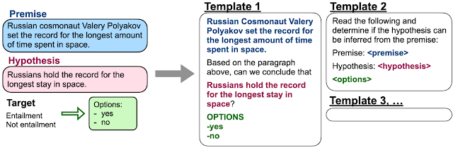

We show that by training a model on these instructions it not only becomes good at solving the kinds of instructions it has seen during training but becomes good at following instructions in general.

